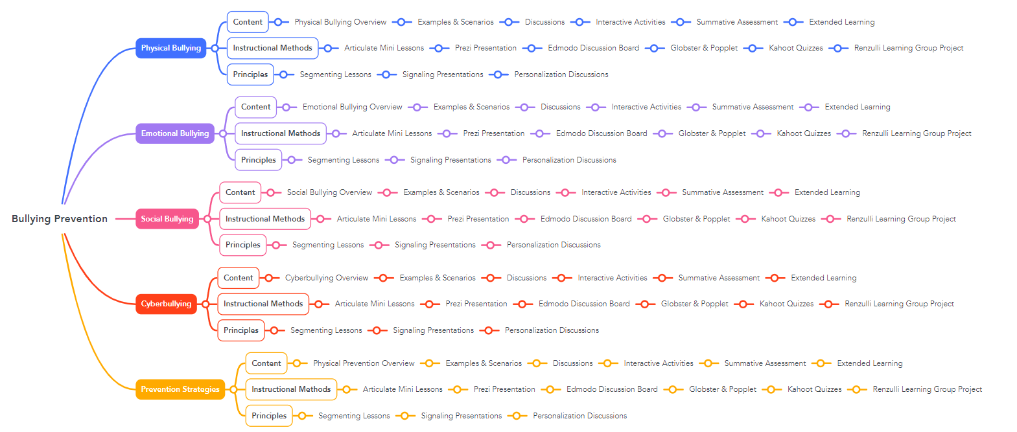

This is a Mind Map for a bullying prevention course for middle school students. I selected this course because it is currently a course that required multimedia implementation. Usually, this course is taught in a traditional face-to-face instructional format. This course targets the various types of bullying and way to prevent it. The headers are the 4 different types of bullying and prevention strategies. Under those headers are the sub-headers: content, instructional methods, and principles. The content sub-header explores the material that will be taught in this course. These instructional materials consist of is a lesson overview, examples and scenarios, class discussions, interactive activities, summative assessments, and extended learning. The instructional methods sub-header are the multimedia resources that will be used to facilitate this lesson. These multimedia resources are using Articulate for mini-lessons of the lesson overview. Prezi presentations for examples and scenarios. Edmodo discussion boards for class discussions. Globster and Popplet for interactive activities. Kahoot quizzes for summative assessments at the end of lessons. Lastly, Renzulli Learning will be used for extended learning group projects. The Segmenting Multimedia Principle will be used for chunking lesson overview content. The Signaling Multimedia Principle will be used in Prezi presentations. The Personalization Multimedia Principle will be used to personalize class discussions.

